Table of Contents

Bartek Ingredients - data and report modeling 2

Document purpose 2

Business background 3

Business domains 3

Describe how customer purchase products or services 3

Basic Bartek production order process 3

Project background 4

Other background information 4

Organization questions answered using business intelligence/analytics 4

Current environment challenges and concerns 5

Project stakeholders 7

Initial general observations 7

Level of current and desired analytics 21

Project goals 21

BI roadmap - 1 22

Initial project design decisions and assumptions 23

Project success factors 23

Project development strategy 24

Data Sources 26

Environment 32

Existing networking environment 32

Priority dimensions 33

Priority facts 33

Report user environment 34

Existing related solution tools and services 34

Power BI Premium capacity/user features 35

Common calculation rules 35

Metrics 35

Slicers 35

Existing applications 36

Existing reports 36

BC_FGInventory_CofA 39

Commerical Netback 40

Environmental Unified 42

Commerical Netback 42

Off Spec 44

P2-Data 45

Process (Unified) 47

Quality (Unified) dataset 52

Release production orders 55

High-Level P1 Ops Dashboard 56

Type - Operational dashboard 56

P1 Operational Dashboard 58

Automation opportunities 59

Existing workflows 59

Workflow production 60

Tools 60

Development teams and roles 60

Version control 61

Project management tools 61

Change management and adoption 61

QA and Deployment process 61

Data archiving 61

Color scheme 61

Desired processes 61

Color scheme 62

Development process 62

Workspace access 62

# Bartek Ingredients - data and report modeling

* Last updated: 11/3/2022

## Document purpose

This document provides an overview of the existing business domain, user personas, and related IT artifacts. It allows Solliance to understand the current environment quickly, suggest areas of improvement that may be a better fit for the organization, and envision the possibilities. The client and Solliance can be better aligned moving forward. Once the project team decides on the priority areas, a roadmap can be created encompassing the goals. The document content will be updated as more knowledge is shared in various meetings. The information is a snapshot in time and is not meant to be perfect. The goal is to gain initial context to make the team more efficient and ensure the deliverables mesh with the current organizational culture. This type of alignment helps avoid rework. The document’s target audience is the project Data AI developers. Descriptions are meant to be brief and fragmented. Goal - disseminate information fast.

## Business background

Bartek Ingredients is a specialty chemical manufacturer serving food & beverage and industrial end markets. Established in 1969, Bartek Ingredients Inc. is a leading producer of malic acid, fumaric acid, and maleic anhydride. Headquartered in Stoney Creek, Ontario, Canada, Bartek employs 120 people across its two production facilities in Southern Ontario. Bartek’s facilities are registered to the ISO 9001:2015 Standard. Bartek also holds the BRC Global Standard for Food Safety certification, and it distributes to more than 40 countries around the world. For more information about Bartek, visit bartek.ca.

* Malic & food-grade fumaric acid, pectin (classified as a chemical manufacturer)
* What is the metric that drives business **success**? e.g. Product pounds shipped per time period. This month, quarter, and year.
* Employee count: 170

## Business domains

* Sales
* Production
* Inventory management
* Customer delivery engagement

## Describe how customer purchase products or services

* How do they place orders?
  + Product group and granularity. Pounds.
* What is the average delivery fulfillment duration? Parameters?

## Basic Bartek production order process

The product is created in batches. Each batch **could** go through a 23 step process. Depends on the batch.

* Step 6 is a very important step. Pot temperature and pressure is measured.
* Step 20, 21, 22 are not tracked all of the time. Depends on the batch being produced.

Note: Confirm with client.

## Project background

* What is this phase reporting focus? Strategic or operations? Revenue or expense?
* How long did it take to create the of reports and reports?

## Other background information

* Two production plants
* One to be commissioned
* One to be decommissioned
* The new plant will be completed in Q4 2023 and will double the company’s existing capacity.

TODO: Confirm

## Organization questions answered using business intelligence/analytics

Reports are meant reduce the amount of time required to make business decisions and drive users to action. Most reports have an initial question or premise in mind.

### Current questions answered

* Strategic
* TODO: Discuss with Bartek
* Operational

1. What is the status of each customer order?
2. What are the Lot Numbers associated with a customer order?
3. What is the current product weight (pounds) in each release code state. e.g. on-hold, ok-to-ship, shipped, rework, reworked.
4. Which product has the most rework per period of time?
5. Which warehouse has the most rework per period of time?
6. Where is the location of each pallet in the plant and status?
7. Where is each customer order located in the warehouse?
8. What is the shipping delay reason? What is the occurrence of delays? Why does it occur?

TODO: Confirm these questions.

### Desired questions

1. How long does it take to move from one stage to another stage? e.g. Ready to ship to Shipped.
2. What is the average spoilage (rework) metric per product? What is the threshold? What actions are taken?
3. What is the average time required to fill an order?
4. What is the average profit per product?

TODO: Confirm these questions.

### Questions for Bartek

1. What are the organizational production goals this year?
2. What do you consider early warning signals?
3. What is the industry standard order to ship duration?
4. What are your workflow opportunities for improvement? How are you measuring them?
5. How are you measuring KPI growth?
6. What is the industry spoil rate?
7. Do you have any key metrics you are trying to optimize?
8. What does MOD_RC mean? Modified release code? How is it used?
9. Do you have a plant layout and codes associated with location areas in the warehouse/plant?

## Current environment challenges and concerns

* What is the current report user creation and change adoption process?
* Users want the data refreshed faster. Scheduled refreshes takes 30 minutes to refresh. 30-minute old data is useless to the operations team.
* Data model reuse.
* Report data trust
  + Data model validation and governance.
* Data flow/refresh monitoring
* Business logic spread. Business logic changes will create friction as many things need to change.
* Missing a change leads to inconsistent data and trust issues
* Cleaning the same data on a repeated basis for multiple datasets is not efficient
* Bugs can be re-introduced during changes
* Mapping legacy to current data is required for any BI solution.
  + TODO: Explore the associated business reasons and costs.

### Project concerns

* Steven is concerned Power BI dataset models cannot be consumed and used in Excel very easily. He needs to understand the process and verify this solution will work.

TODO: Confirm

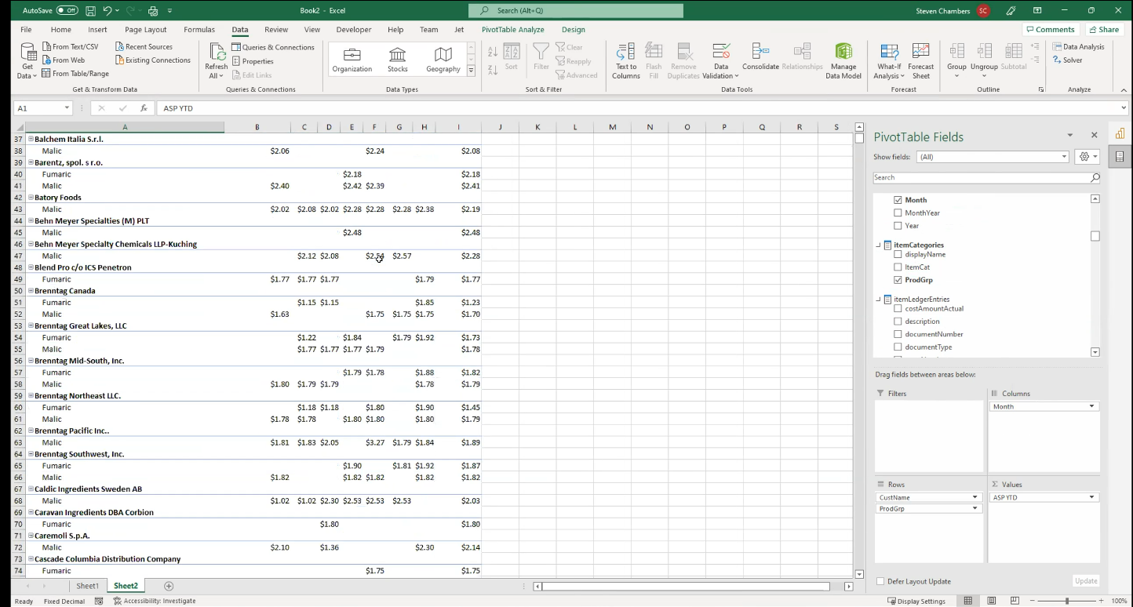

### Predicted challenges

* Data source schema changes
* SaaS LOB insulation. Bartek needs the ability and path to switch SaaS vendors without losing the ability to capture and report on critical operational data.

### Current reporting

* What are the current organization’s reporting gaps?
* Are there performance concerns?

#### Data and reporting accuracy

* What is the perceived and measured data and reporting accuracy? Is there a current tool to capture user requests and errors? Tie the requests to a report or data area.

### Report user working teams

1. Commercial sales
2. Plant production
3. Executive leadership

## Project stakeholders

### Bartek

* Steven Chambers - CFO - steven.chambers@bartek.ca
* Eric Turner - Senior Analyst, Advanced Analytics - eric.turner@bartek.ca
* Kamil Salagan - Manager, Infrastructure & IT - kamil.salagan@bartek.ca

### Solliance

* Lino Tadros - IoT lead
* Dan Patrick - Infrastructure lead
* Carey Payette - Azure Synapse Analytics lead
* Ike Ellis - Lead and Data AI architect
* Tim Henning - Power BI Developer - timh@solliance.net

### Communication preferences

* Teams?

## Initial general observations

Creating good BI reports and artifacts is all about iterating and refining your model and reports. Based on your previous efforts, you know more about your users’ reporting needs and what can be improved. You have learned. As part of your improvements, you need to figure out how to make the current assets maintainable and performant to meet the next set of business requirements.

The goal is not to provide a rating of the current state because there is always a better report. For example, Power BI is updated every month to meet the changing business demands. It has evolved over the years and so should your architecture, designs, and reports.

### Current architecture and solution considerations

1. Does the current solution provide the answers the business requires?
2. Does the solution fit the organization and project budget?
3. Will the solution scale and provide sufficient performance to meet the upcoming needs?
4. Can the current operations and development team maintain and expand the proposed architecture?
5. Are the organizational users happy with the reports?

### Current BI assets

The current BI team has created many Power BI reports. There is a fundamental understanding of how the tools work and the development process. The Solliance team can assist in refining the processes and provide suggestions on best practices.

TODO: Based on the existing data models and reports, the Solliance team would like to understand any data insights learned so far.

### Types of analytical reporting

1. **Descriptive** - Data assessment and exploration - surfacing data beginning aggregation or curation. Addressing basic organization reporting needs. Determining data granularity. What attributes drive the measure values. Descriptive analytics - what has happened in the past. Start to begin data monitoring based on priority. Understanding the data thresholds. Min, max, and averages. Report filtering can be fine tuned allowing for a personalized view of the data. Alerts can be created based on priority values that land outside the thresholds.
2. **Diagnostic** - Why did this happen? Determine causation and effects.
3. **Forecasting/predictive** - Requires an excellent understanding of the data and dependent processes. Using historical data and trends, the organization would like to predict future values and understand the probability of occurrence.
4. **Prescriptive** - based on option analysis, what actions should be taken. View and recommend the best course of action before making decisions.

#### Initial thoughts

* The current reports are descriptive in nature.
* Using target goals in Process (Unified). Perhaps move the goals to a central dataset.

TODO: Confirm

### Requirements gathering process

Solliance needs enough time to explore the current reports and data to provide some options to iterate from and gain inspiration - gain context.

* What is the main purpose of each report and what are the insights gained so far?

TODO: Need report review working sessions.

### Data modeling

#### Main data lineage

Using chained/layered datasets. Looks like the strategy is to use UnifiedDataModel as the datamart. The current set of datasets don’t have many measures. Lots of calculated columns.

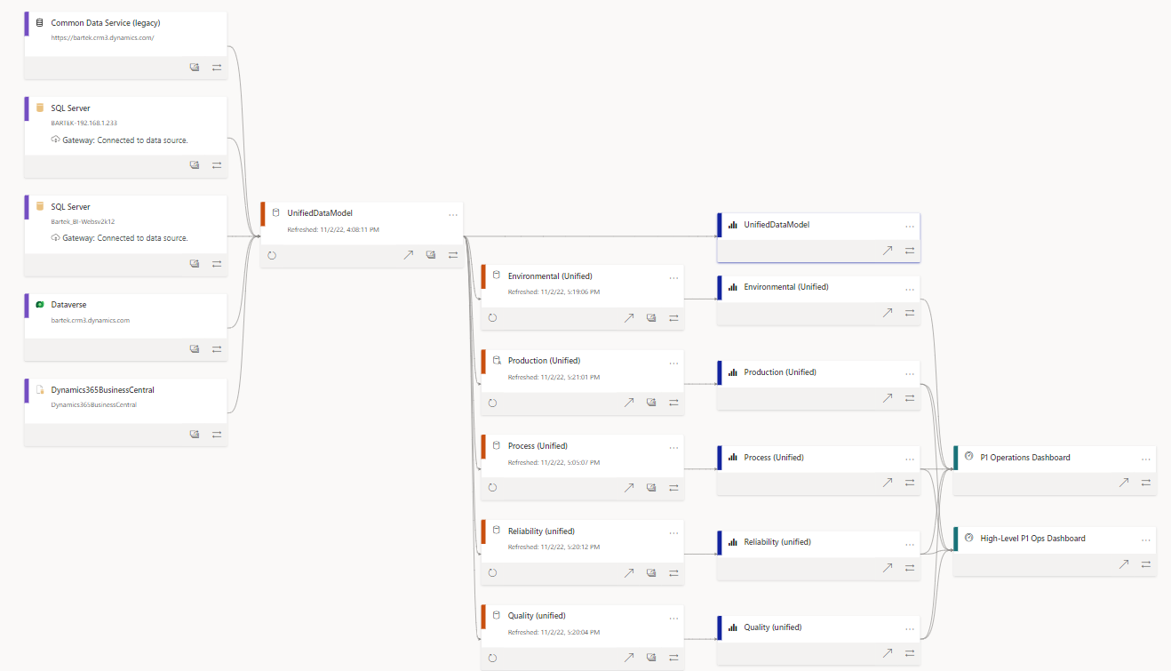

#### Database

* **Make use of database schemas** segment the data and protect the data warehouse tables. Associate objects with general organization usage and semantics. Generally, schema names should not change frequently. It does provide a clues as to the intended usage and the teams to consult. Separate permissions can be applied to schemas. It can prevent accidental updates to views, stored procedures, and functions.

#### Current Power BI Data modeling observations

* Inconsistent naming conventions.
* 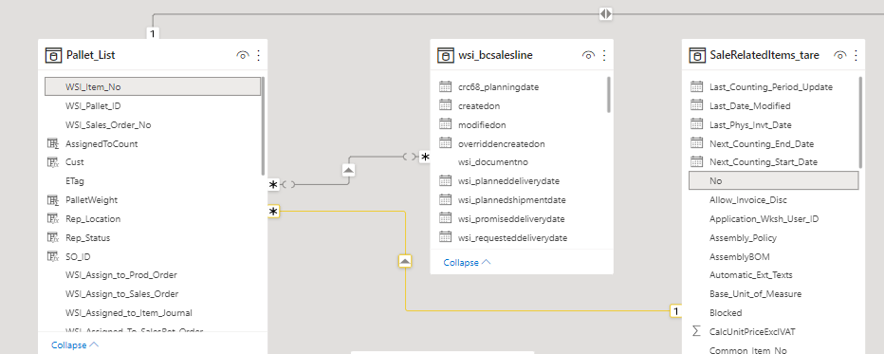
* Reason: - **Inconsistent field and table naming conventions**. This makes it difficult for other developers and the user community to quickly leverage the model. Inconsistency leads to errors and increased QA time.
* Many to many relationships
* 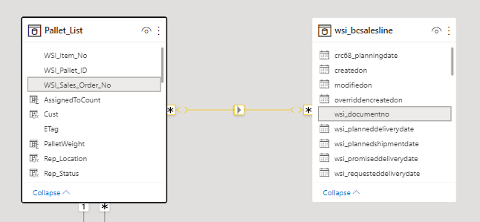
* Reason: Which table do I use for additional reporting and filtering? Report builders will get confused. When you want to create a slicer, you suffer a performance problem because now you have scan the whole fact table to find the distinct values. And you are not sure you got all of the values for that dimension. What happens of one fact table has some values the other fact does not have? Your slicer or filter context will not be complete. It makes creating measures difficult later. You will get varying results. Exception to this rule: Depends on how you slice your data. Do you have a bridge table? You will need to test.
* Note: Need to understand the usage context and the data.
* Bi-directional relations
* 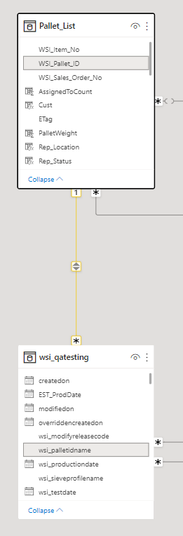
* Reason: Computing values in measures will be unpredictable. Use it sparingly. Transforms the model. Creates ambiguous relationships. A table with multiple relationship paths to another table is said to have an ambiguous relationship. Which path will the engine take to query related data? You cannot be sure. Will the aggregate totals be correct? You have to remember to remove relationships in your DAX code explicitly to force the desired path.
* Note: Need to understand the usage context and the data.
* Blank values
* 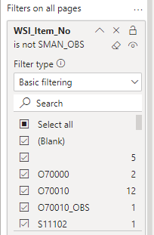
* Reason: Blank/space values in your slicer usually indicate there is a referential integrity data issue in one of your fact dimension relationships. This could lead to incorrect totals and aggregate measure values. You have to remember to turn on items that have no value. Power BI will insert an artificial row, depending on the function. For example, VALUES will contain the values, plus the blank row. Table references will not count the blank rows. DISTINCT does not compute blank values. ALL references the blank rows. COUNTROWS, by default, does not consider the blank row. Better to fix the data and invalid relationships. Filtering out blank rows may be returning invalid data. Blank rows can also cause circular dependencies. You need to replace functions that reference blank rows. For example, replace ALL and VALUES with ALLNOBLANKROW and DISTINCT.
* Relationship data might not match
* 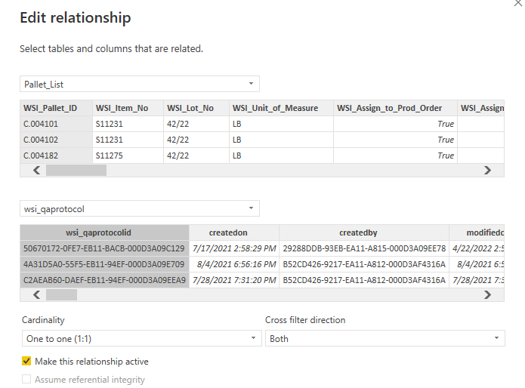
* Reason: Incorrect relationships will produce undesired or incorrect reporting results.
* Relationship keys are not integers
* Reason: Relationships built on integers perform much better than text values.
* Hide foreign keys away from report creators.
* Using a lot of date hierarchies
* 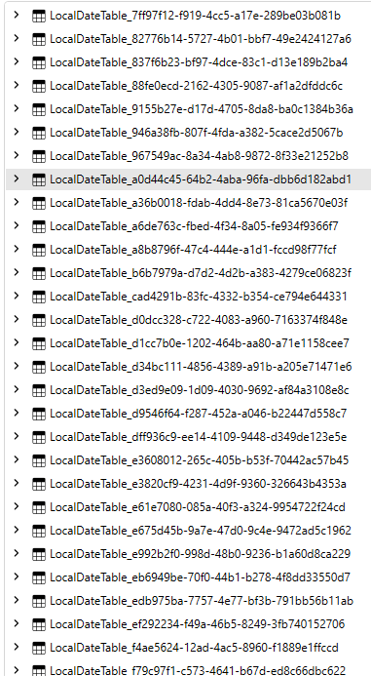
* Reason: Using more storage than necessary. Power BI is going to take longer to refresh the data that you might not be using.
* Need to mark date tables as a date table. Performance reasons.
* 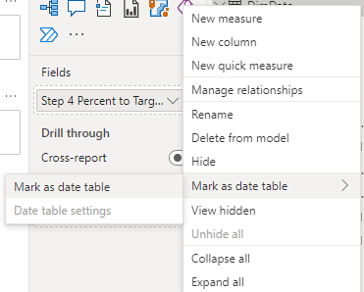
* Reason: When using the date table, the relationships are based on a date a column and data type. The Vertipaq engine automatically removes the filters for appropriate time-based calculations. Using any other type of data type, like integer, it will not automatically removed. Your calculations might be incorrect.
* Multiple workspaces might help with organization and process
* 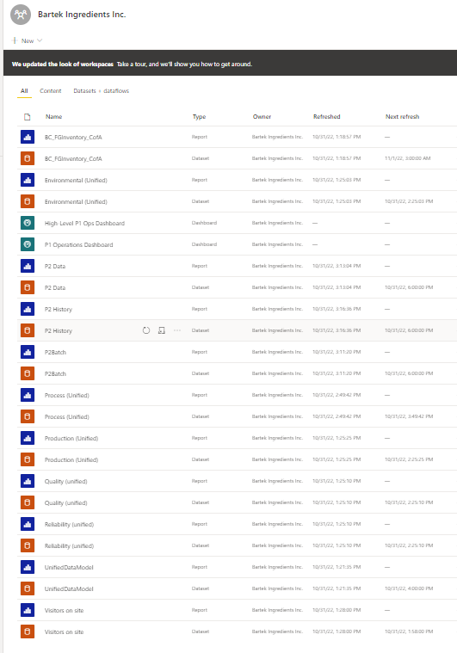
* At a minimum, you should have a DEV and PROD workspace. You will want to limit the amount of development in personal workspaces.
* Consider breaking out time away from timestamp
* 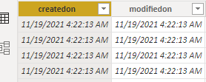
* Consider using date data type instead of date/time
* 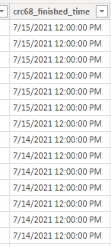
* Reason: Better performance. Taking up more space in memory.

### Visualization observations

* **Wall of data problem.** Prevent users eyes from scanning the entire page. Use other visuals to direct the reader to points of excellence and problems. Company is spending more money because the report users are not using the report efficiently. Time is money. Multiply the problem by the amount of users.
  + Surfacing the database tables/queries in Power BI without driving actionable decisions.
* **Alerts** - Not making use of key field thresholds. When problems arise, the user should drill down to details.
* **Abbreviations in the report labels**. Users and developers will need to decode the label. Extra cognitive cycles are spent initially.
* **Limit the visualizations** to 5 - 7 or less per page. Human beings have an 8 second attention span. Focus their attention on a question and group related data quickly.
* **Use color, fonts, and whitespace to emphasize values and focus the attention**.

### Large datasets

* Do any of the reports contain large datasets?

### Query parameters

* Do any reports require parameters for data refresh?

### Incremental refreshes

* Is the data partitioned? No.

### DirectQuery storage mode

TODO: Confirm if any reports are using DQ.

* Do your reports require large datasets? > 1GB
* Do you need up to display the most recent data?
* Do you understand some of the limitations?
  + For example, certain DAX functions cannot be used. Non-additive functions.
  + Drill down by using year, quarter, month, or day is not available.
* Every visualization is going to execute at least one query. Multiple users and filtering can issue many queries at once to the data source.
* Using DQ in a few reports.
* DirectQuery PBIX files
* DirectQuery storage option can produce many queries to the back end data source. You need to reduce the amount of queries each visualization sends to the database. You might want to consider turning off automatic filter. Was there a business need for DirectQuery?
* 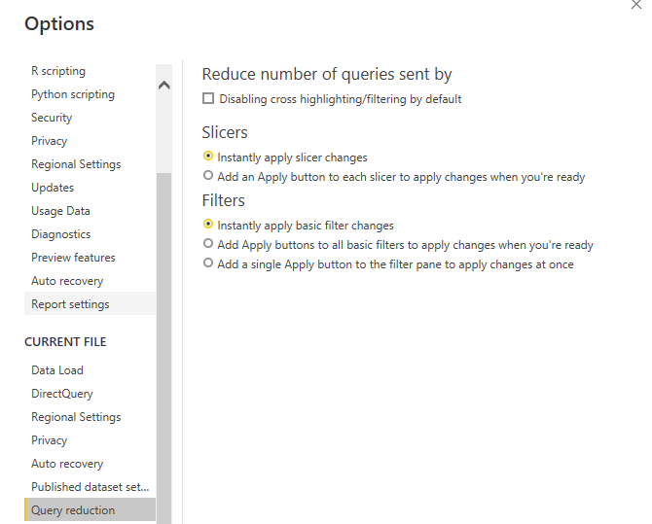
* Limit the connections
* 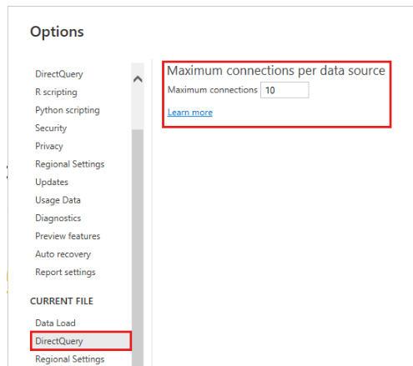
* 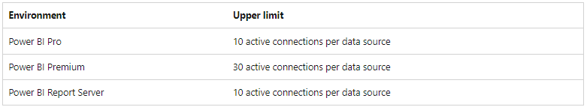

### Composite models

Do you have mixed data sources in one PBIX? Database and Excel?

### General data filtering and expression requirements

1. When does the fiscal year begin?
2. Are the report users in the same region?
3. What are the really important date fields?

### Deferred maintenance

1. Unused objects reports, queries, tables, fields, measures.
2. Processes that need to be turned off or refactored?

### Other questions

1. Are reports emailed around? Shared folders?
   * Excel
   * PDF
   * Images

## Level of current and desired analytics

* **What has happened?** Understand the causes and events. Evaluate data trends.
* **What should happen in order to meet a goal?** What if parameters. Current state and goal comparison.
* **What will happen?** Predictive analytics based on historical/industry data.

TODO: Get client confirmation of phase goal.

## Project goals

* Understand organization BI objectives.
* Validate the DW structure and data.
* Create well defined validate data marts for users to connect to via Excel and Power BI. The data mart would provide the well-defined shared data elements applications and reports could use.
* Improve reporting data freshness for certain use cases.
* Display critical KPI metrics in dashboards. Allow users to drill into the details.
  + Manage by exception.
* Create push notifications for high priority KPI thresholds.
* Deprecate the old reports and/or data sources.
* Demonstrate effective report design.

TODO: Get client confirmation of phase goal.

### Future state report design

* Judicious use of color to warn, inform, and emphasize.
* Trend-lines to show results of previous decisions.
* Data comparisons to goal to see length of distance left to achieve the goal

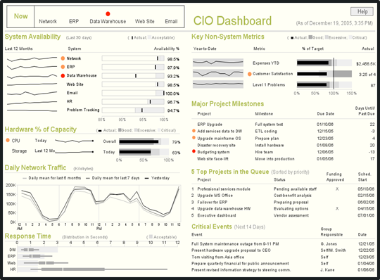

### Project phase domain focus

Need to effectively manage the business. Focus on Dataverse and ERP data and analytics. - Steven

* Inventory the business questions current answered and that need to be answered via analytics.
* Inventory existing reports and document use cases.
* Determine business domains focus. Mock up reports based on existing reports and desired improvements. >TODO: Why are the users downloading the report data source? **Review user community created reports**. What questions are they answering with the data?
* Use new reports to validate the DW data pipelines, structure, and data. Compare new reports with existing reports.
* Deprecate the old reports and/or data sources.

TODO: Get client confirmation of phase goal.

## BI roadmap - 1

### Milestone possibilities

* Architecture Design Session - data and artifact review.
* Development team set up
* Goal creation and curation
* Organization prioritization alignment
* Change communication adoption strategy
* Identify 1 - 3 reports to drive DW model and data validation. Validate the data granularity.

## Initial project design decisions and assumptions

* No need for other data aggregation and data partitioning software. If the dataset is less than a 1 GB, then Power BI datasets are more affordable. Otherwise, consider using Analysis Services. The monthly hosting would be affected.
* If Bartek is interested in providing a customer BI portal interface for shipping status, then Power BI premium capacity might be a good choice. The price starts at $4995 per month. A deeper look at the labor costs involved with customer shipment delivery might be interesting. Need to engage a representative sample of Bartek customers to determine interest and possible use cases. Steven believes document management is more of a focus for this use case. e.g. Certificate of Analysis. This is not the highest priority at the moment.
* Going to stick with Power BI and Excel tools. It is a sunk cost and the other options don’t provide real switching benefits based on Bartek’s business needs.
* We are going to focus on the ERP operational reporting needs.

## Project success factors

### High-level strategy

* Tactical operations - Operators need reports. Need data for the legacy plant. Status of production orders is critical to understand and referenced several times a day.
* IoT data is a different state. Separate project.

### Leadership benefit story

#### Examples

* Business question never answered before.
* Business question answered faster than before. Faster decision making capability.
* Insights that drive increased revenue and profits.
* Risk reduction.
* Sales and cost forecasting. What if scenarios.

### Operational user benefit story

#### Examples

* Fewer steps required to complete daily tasks.
* Operational problem identified/prevented sooner.
* Operational trends.
* Operational forecasting. What if scenarios.

### Measurements of success

* Capture process scorecard metrics before the project
  + Is this information available now in BI? How long does it take to surface?
* Interview stakeholders
  + Capture key quotes related to challenges
  + Capture how the stakeholders are making better business decisions
* Report usage metrics over time
* Feedback
* Observed behavior change

## Project development strategy

Because Bartek has created many reports and met the targeted users initial requirements, Steven would like to focus on the data model first. Once the data model is created and data has ingested then he would like to focus on the reports.

### Communication and documentation usage strategy

* Email
* Direct Message - Microsoft Teams
* Status meetings
* GitHub
* Key decisions are stored?

### Desired development environment

* Dev, Test, Production

TODO: Are there QA resources?

### Number of current Bartek developers

### Mix development teams?

### Tasks

1. Identify reports that will exercise a good portion of the data warehouse and dataset models.
2. Determine the data granularity
3. Validate the data.

### Multi-layered data design

* Land the basic data, filter it down, and transform it based on need. Make it possible to debug issues easily.

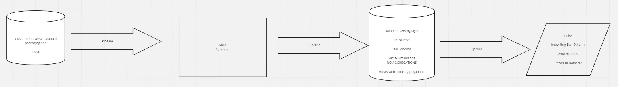

### Shared dataset

* What entities and measures should be wrapped in one datasets or layered datasets? We need to identify domains that can be segregated into datasets.

### Power Query connection parameters

* Parameterized connection. Make it easy to switch between environments. DEV vs TEST vs PROD.

### Shared theme file and background image

* What are the basic colors that should be used in reports. Define borders, fonts, sizes, colors.
* Background image

### Report data validation strategy

* Read-only access to the data source helps expedite the validation tasks.
* Examples of existing reports with enough data to independently validate new report calculations should be provided.
* Once the report developer has verified the report draft, the report data validation will proceed to the appropriate Bartek resource.

### Target audience feedback

* Existing report and use case feedback
* Mock ups feedback

### Version control and deployment

* Can we make use of dev workspaces? This allows the development team to publish and share artifacts without the users interfering.

### Large datasets

* Review the business case for the large dataset.
* Is the granularity necessary? Can we aggregate? Averages, etc.
* Incremental refresh

### Pre-calculated data

* Does it need to be dynamic or is a static calculated table acceptable?

### Build shared data flow

* Tables/entities that might be shared between reports leverage Data Flows.

## Data Sources

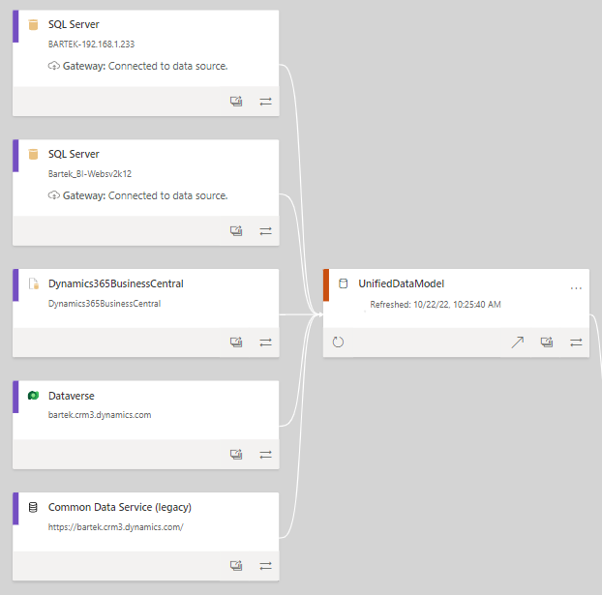

1. Bartek database
   * **Server**: Websv2k12. 2014 SQL Server database.
   * **Overview**: Database built over many years. Catch-all container for all types of projects. Lots of deferred maintenance. Some tables that are no longer being used.
   * **Functional usage**: Raw data tables from many different systems. Old product heirarchy to new product heirarchy.
   * **Client Apps**:
   * **Example structure**:
   * 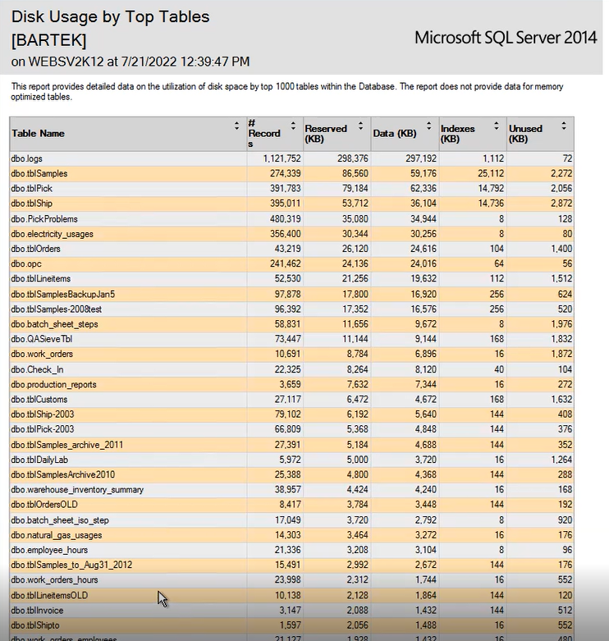
2. Bartek_BI
   * **Server**: Websv2k12
   * **Overview**: Used for reporting data transformation and cleansing. Steven Chambers is the main architect/developer. This database may not be used going forward.
   * **Functional usage**: Reporting data source for existing Power BI and Excel reports.
   * **Client apps**:
     + SSIS: Currency conversion rates. Normalizes the dataset. Data source is Bartek, mostly. Dataset is called from Excel. This could be a good place to start for transformations. 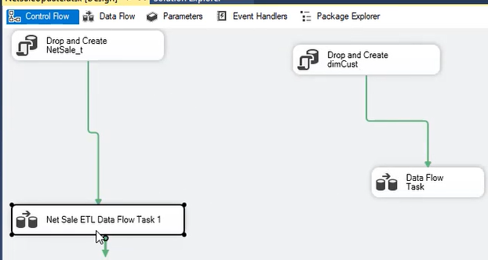 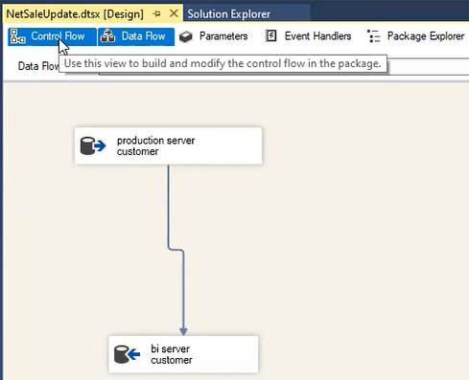 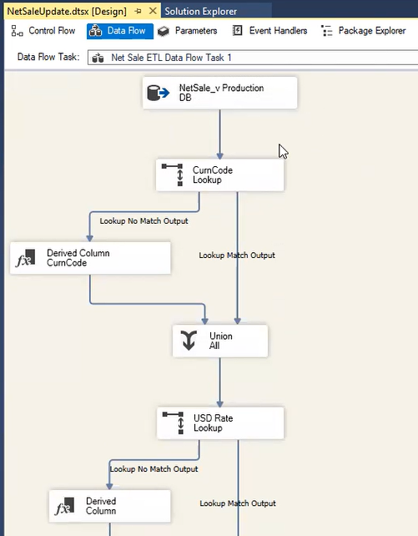
   * **Example structure:**
   * 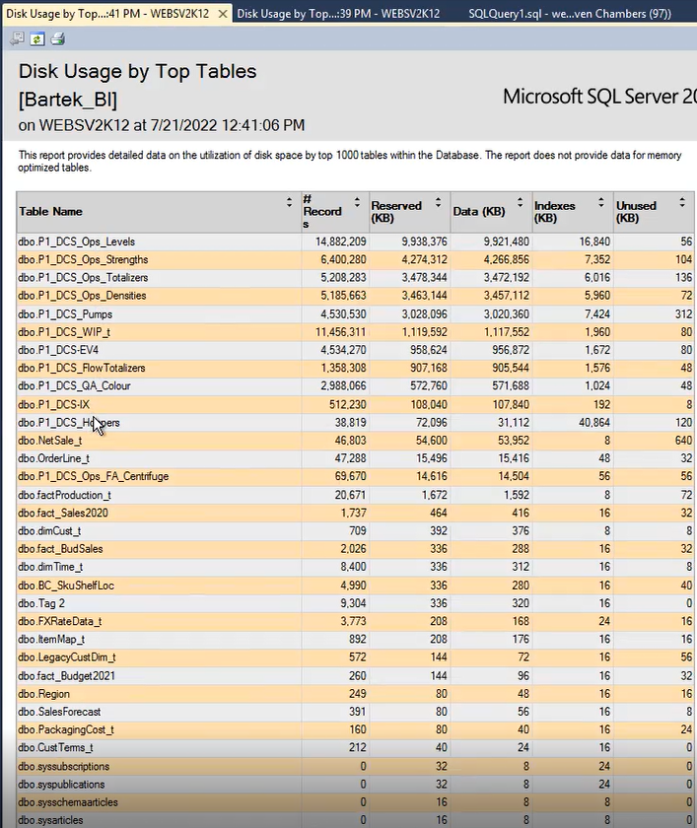
3. Dataverse

* **Functional usage**: Quality data.

1. Dynamics365BusinessCentral
   * **Server**:
   * **Functional usage**: Current ERP
   * Purchase orders

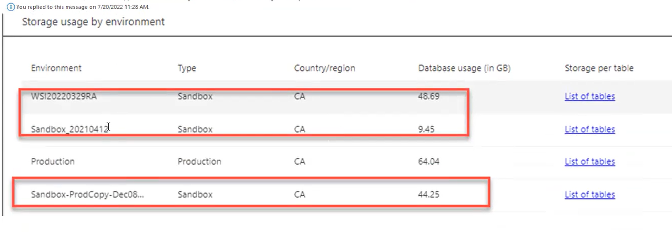

1. Common Data Service (Legacy)
   * **Functional usage**: Legacy ERP

## Environment

## Existing networking environment

* Co-location environment?
* Multiple cloud providers?
* Connection throughput
  + On-site
  + Off-site? VPN connections? Traveling salespeople?

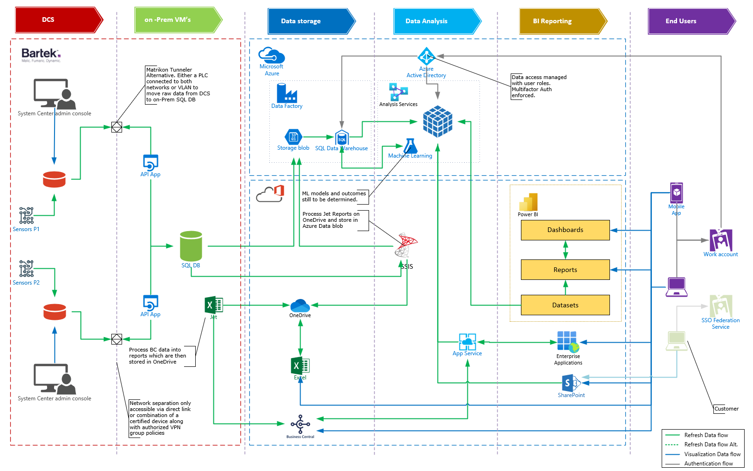

## Priority dimensions

### Customer

* Overview

### Employee

* Overview

### System Equipment

* Overview

### Pallet

* Overview

### Product

* Overview

## Priority facts

### Production

* Overview

### Quality

* Overview

### GL Entries

* Overview

### Inventory

* Overview

### Shipment

* Overview ###

## Report user environment

### Regions

### Domains

* Commercial sales
* Shipping operations

TODO: Get client confirmation of groups.

## Existing related solution tools and services

* Excel
* Power BI
  + Pro licenses
  + How did you install Power BI? Microsoft Store or a specific version?
* Power BI Report Builder (Paginated reports)
* SQL Server Analysis Services (SSAS)
* SQL Server Server Integration Services (SSIS)
* SQL Server Reporting Services (SSRS)
* SQL Server
* Common Data Services/Dataverse
  + What application plan level?
  + How many existing environments?
* Microsoft Dynamics 365
* Office 365
* SharePoint - not implemented
* Custom applications
  + Chron jobs/services
  + Workflows

## Power BI Premium capacity/user features

<https://learn.microsoft.com/en-us/power-bi/enterprise/service-premium-features>

* Paginated reports
* Report embedding
* Sharing reports with non-licensed users
* Deployment pipelines
  + PPU/Capacity
* Large data format

## Common calculation rules

Rules that are used across many reports. The calculation needs to be applied in a consistent manner.

## Metrics

Sales vs goal vs prior year Finance Cash flow AR Production Shipments Workflow (Pallet Packaging)

## Slicers

* Product Group
* Sku
* Granulation
* Batch
* Pallet
* Date/Time - between specific dates.
* Production Order
* Release Code
* Modified Release Code

## Existing applications

### Packaging App DB

* Used in PowerApps for validation, observation & estimation
* 3.5 GB in Size. Connects to Dataverse.

## Existing reports

### Number of report users

* 4 Commercial
* 3 Admin
* 6-8 Operations

### General related report development information

* Currency data gets converted into US dollars
* What is the level of historical data required in Power BI datasets vs DW? 80/20 rule. Create datasets with 10 years?
* Largest PBIX file size?
* Average PBIX file size?
* Need to map old products to new product SKU. Mapping table exists.
* Splitting reports from dataset?
* Using dataflows?

### Functional data structure

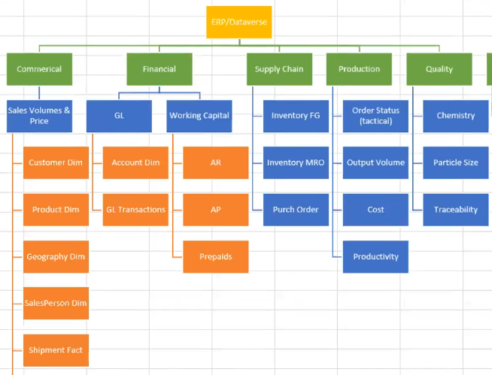

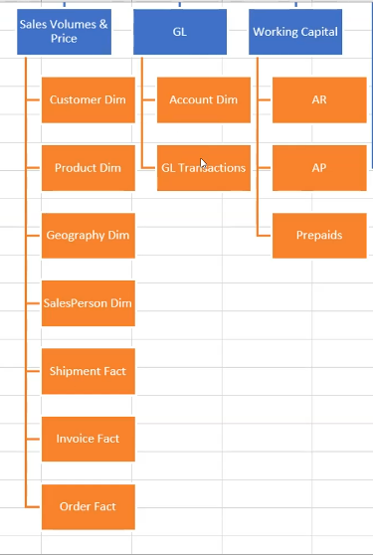

### Report classes

1. P1 Environmental Report
2. P1 Reliability Report
3. P1 Quality Report
4. P1 Production Report
5. P1 Process Report
6. P1 H&S Report
7. P2 Environmental Report
8. P2 Reliability Report
9. P2 Quality Report
10. P2 Production Report
11. P2 Process Report
12. P2 H&S Report
13. Financial Reports

### Report list

## BC_FGInventory_CofA

### Overview

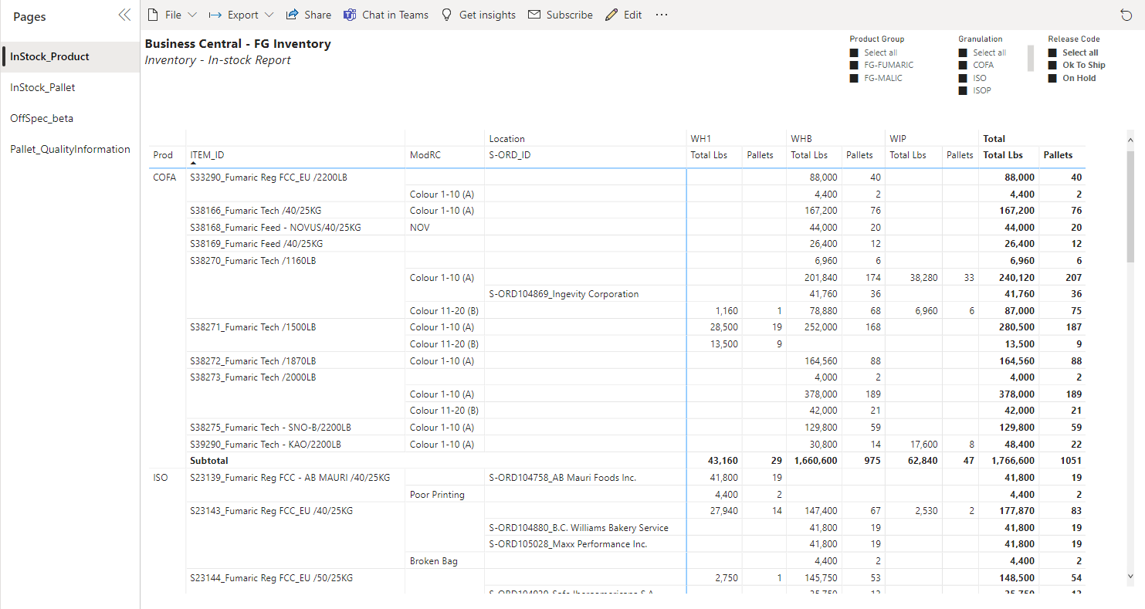

#### Business questions addressed and actions taken

### Data source

### Storage mode and data freshness

### Current usage

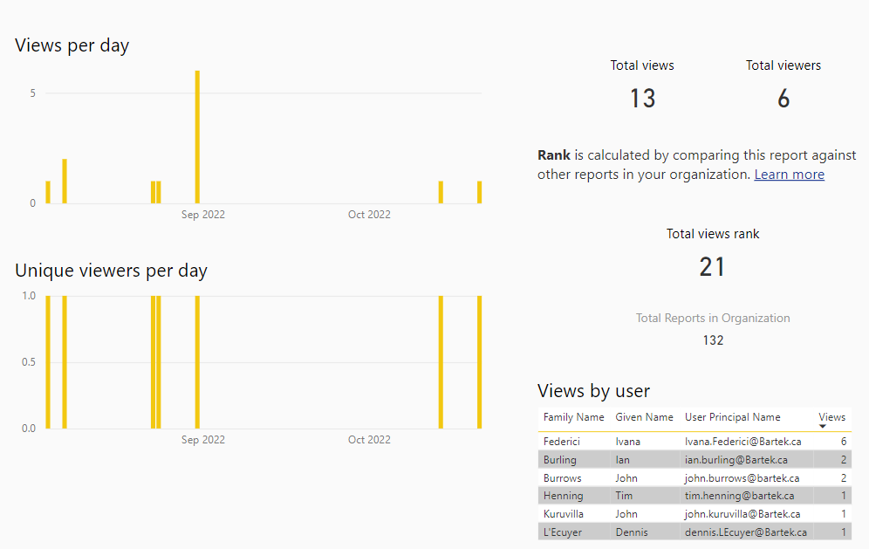

### Target users

### Security and data restrictions

### Value thresholds

### Business criticality (availability)

### Possible improvements

## Commerical Netback

Existing Commerical Netback report example

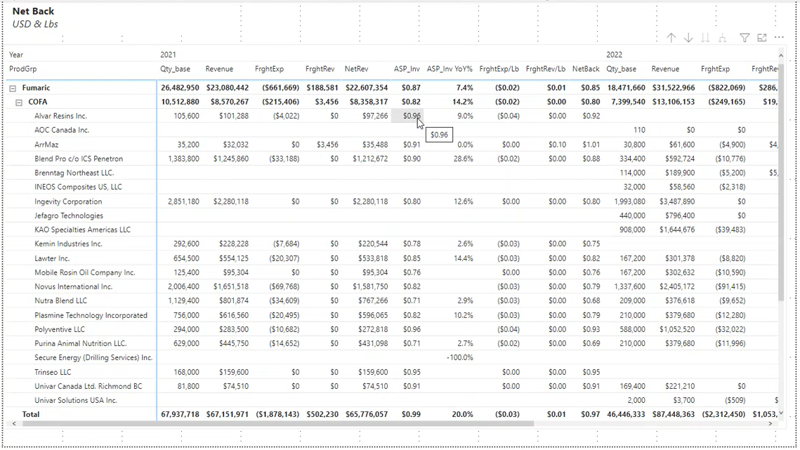

### Overview

The commercial netback is the revenue received for any given transaction. Calculated in the payment terms.

#### Business questions addressed and actions taken

### Data source

### Related tables

### Storage mode

### Current usage

Monthly. Currently, the sales people pull the data into Excel.

### Target users

Sales

### Security and data restrictions

### Value thresholds

### Business criticality (availability)

### Possible improvements

## Environmental Unified

### Overview

#### Business questions addressed and actions taken

### Data source

### Storage mode and data freshness

### Current usage

### Target users

### Security and data restrictions

### Value thresholds

### Business criticality (availability)

### Possible improvements

## Commerical Netback

Existing Commerical Netback report example



### Overview

#### Business questions addressed and actions taken

### Data source

### Related tables

### Storage mode

### Current usage

The commerical sales team will analyze products and the customer and measures in Excel based on the dataset.

### Target users

Commerical Sales

### Security and data restrictions

### Value thresholds

### Business criticality (availability)

### Possible improvements

## Off Spec

### Overview

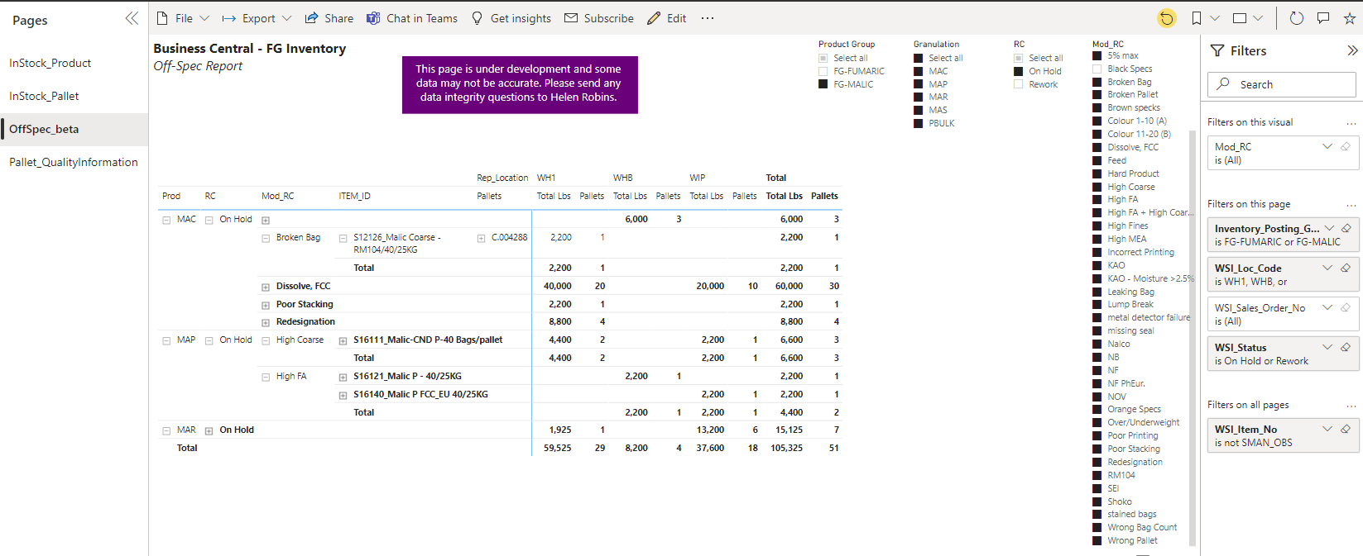 #### Business questions addressed and actions taken

### Data source

### Storage mode and data freshness

### Current usage

### Target users

### Security and data restrictions

### Value thresholds

### Business criticality (availability)

### Possible improvements

## P2-Data

### Overview

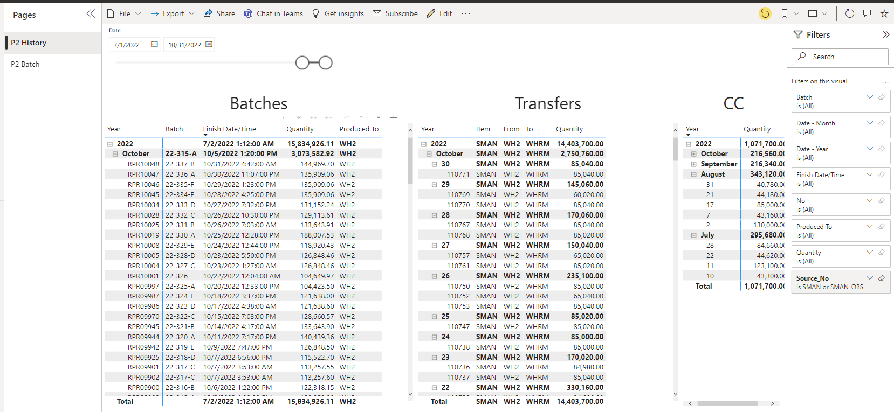

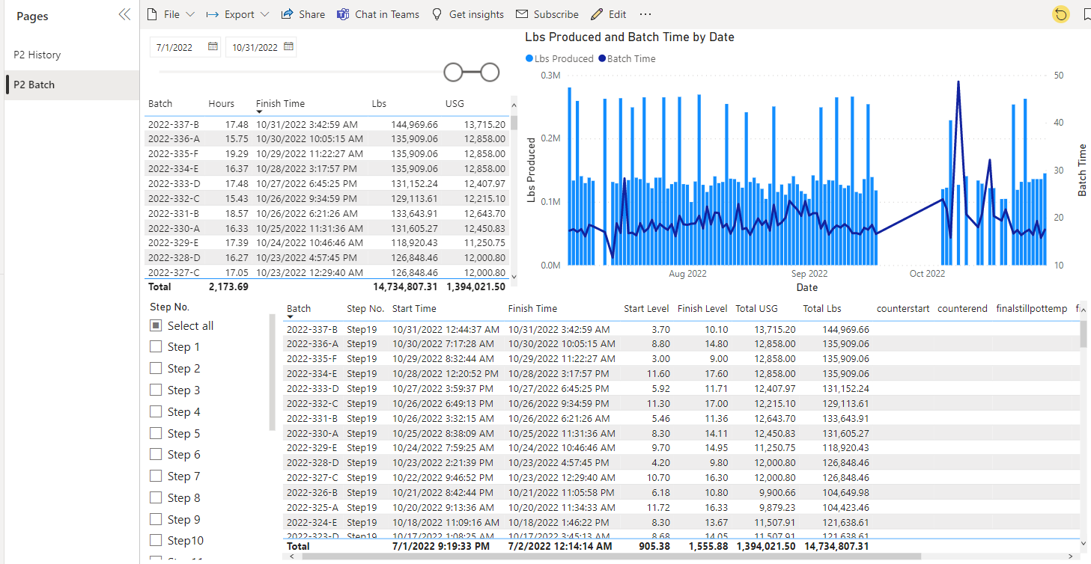

#### Business questions addressed and actions taken

### Data source

### Storage mode and data freshness

### Current usage

### Target users

### Security and data restrictions

### Value thresholds

### Business criticality (availability)

### Possible improvements

## Process (Unified)

### Overview

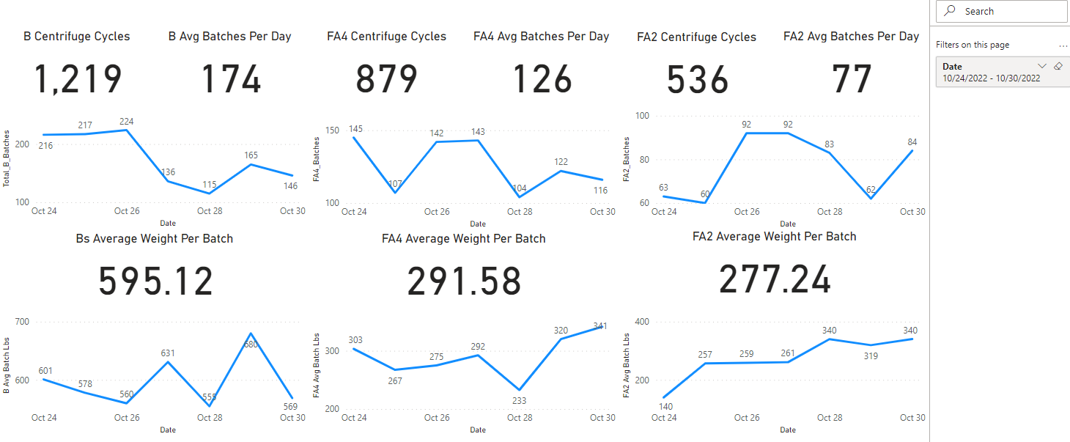

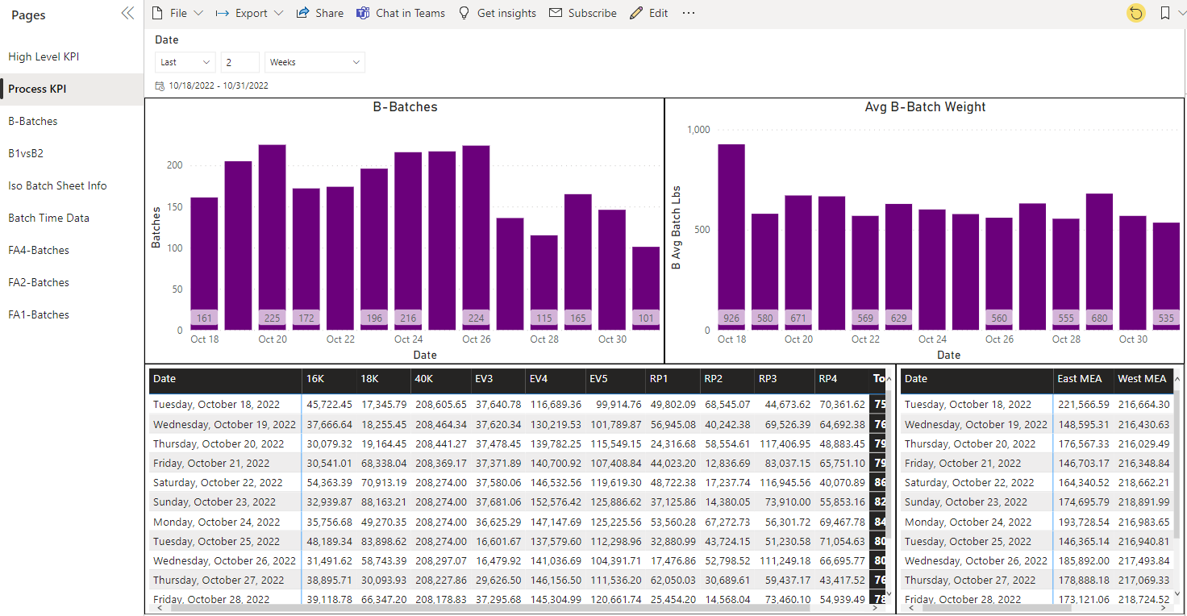

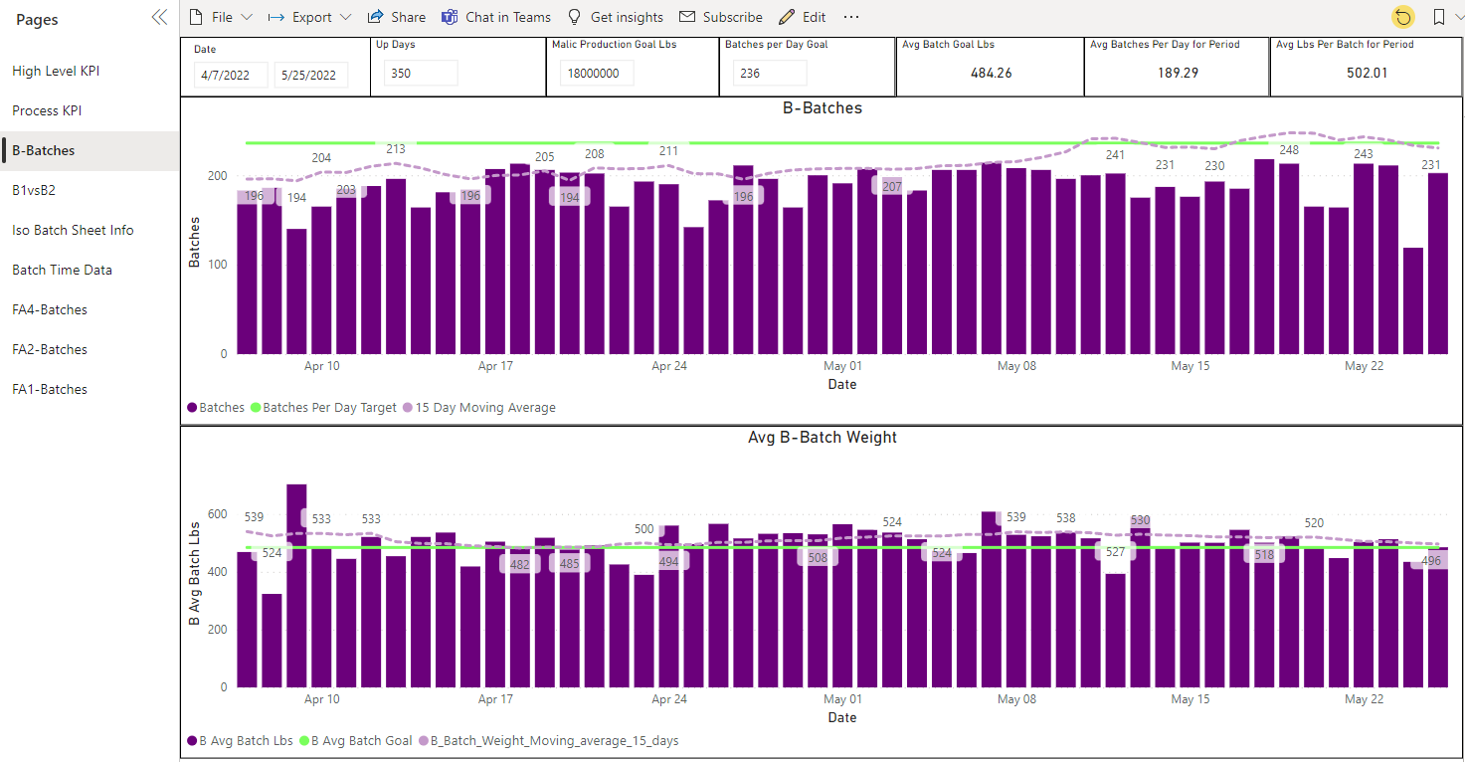

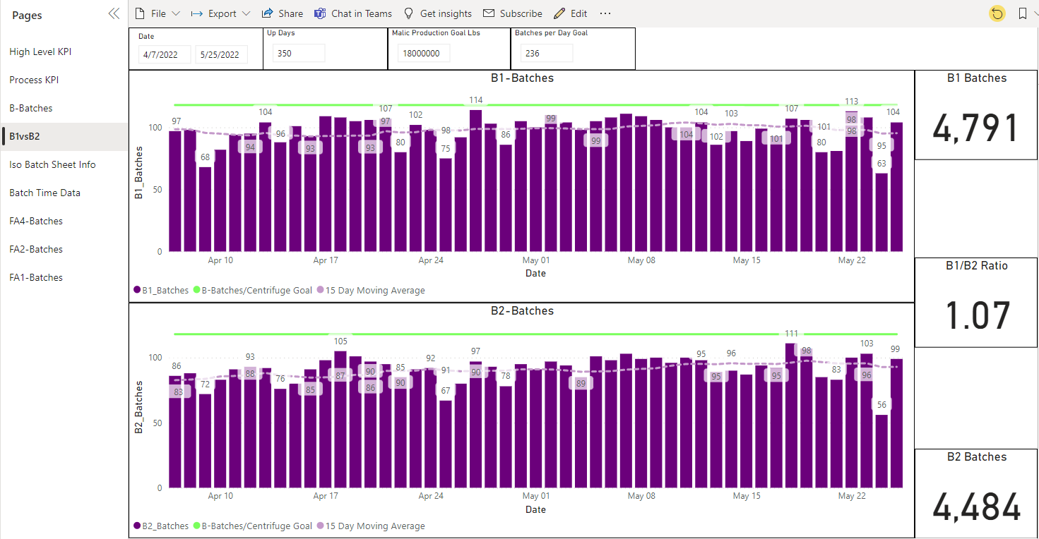

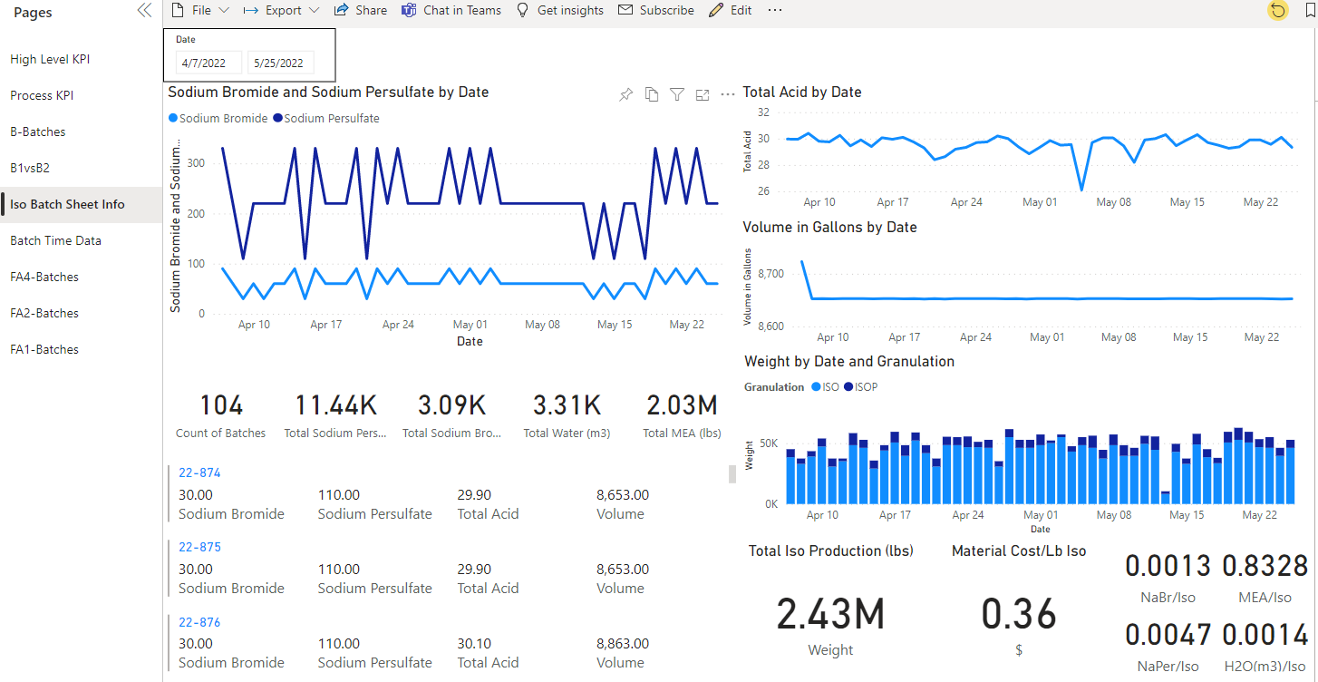

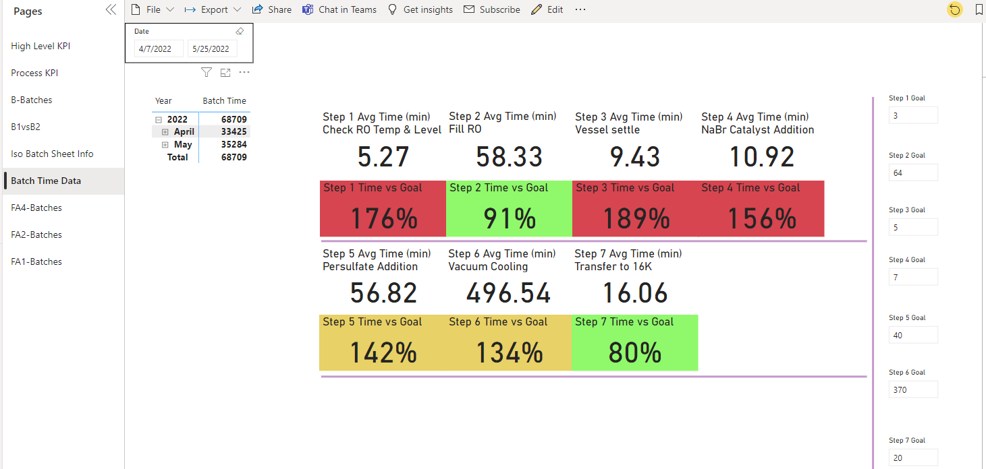

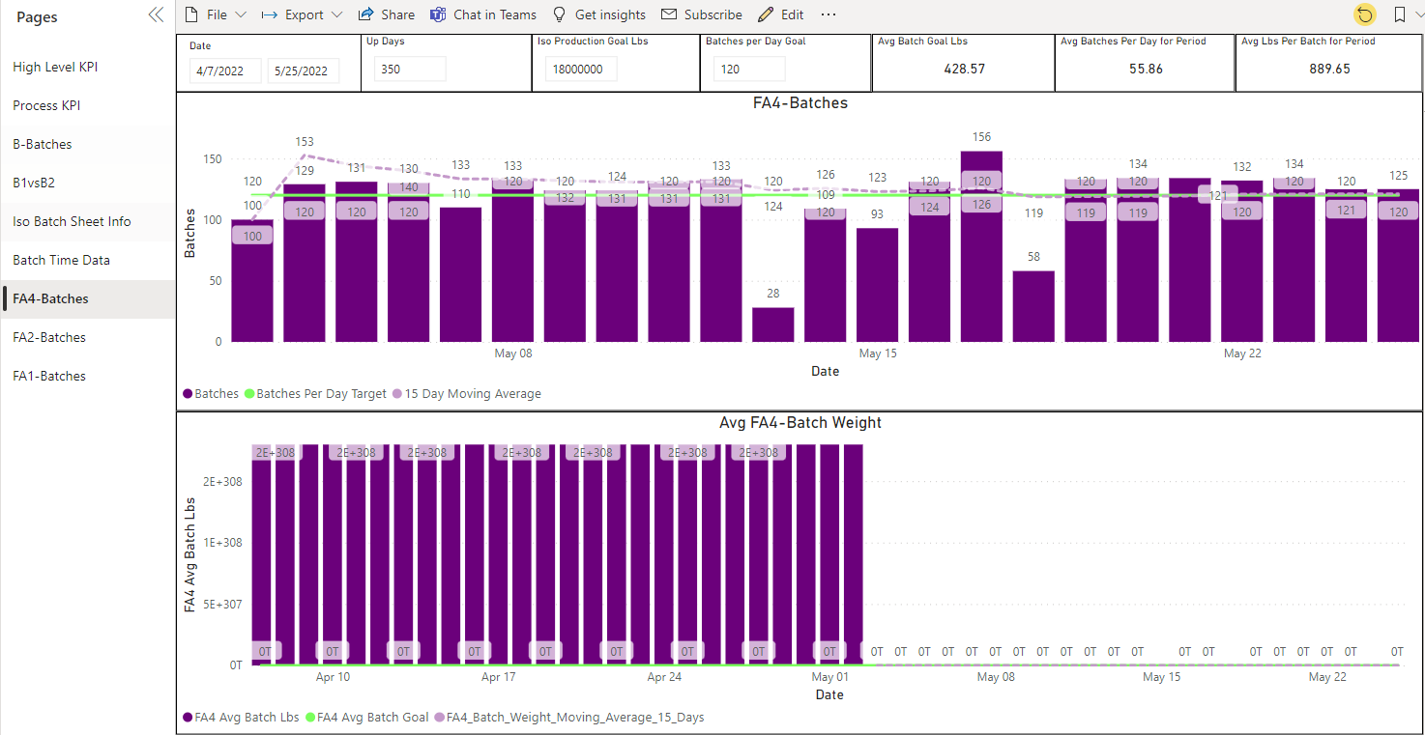

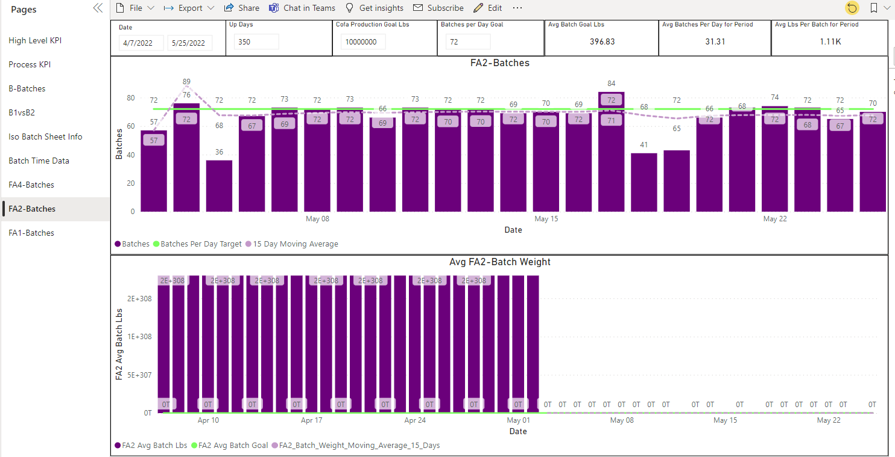

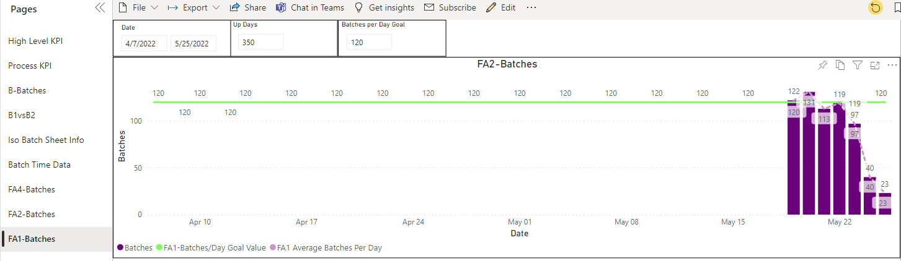

#### Business questions addressed and actions taken

### Data source

### Related tables

### Storage mode

### Current usage

### Target users

### Security and data restrictions

### Value thresholds

### Business criticality (availability)

### Possible improvements

## Quality (Unified) dataset

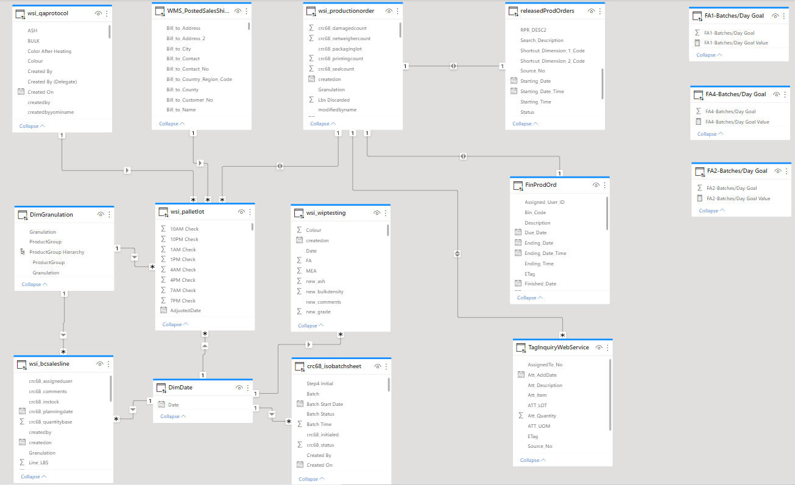

### Important facts

* wsi_palletlot
* wsi_productionorder ## Quality (Unified)

### Overview

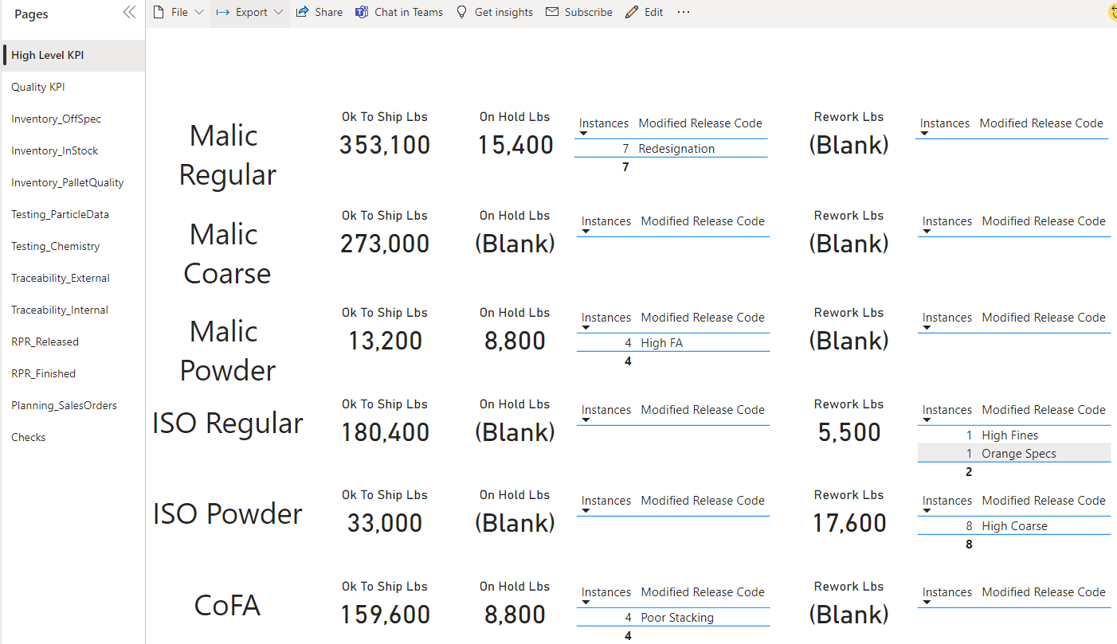

#### Business questions addressed and actions taken

### Data source

### Related tables

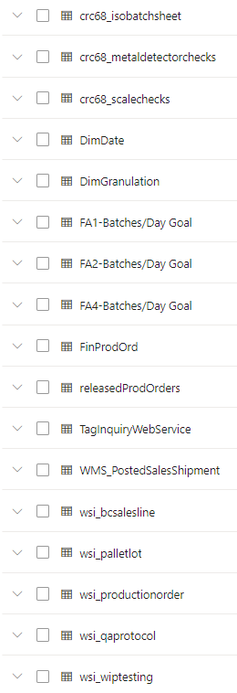

### Storage mode

* DirectQuery

### Current usage

### Target users

### Security and data restrictions

### Value thresholds

### Business criticality (availability)

### Possible improvements

## Release production orders

### Overview

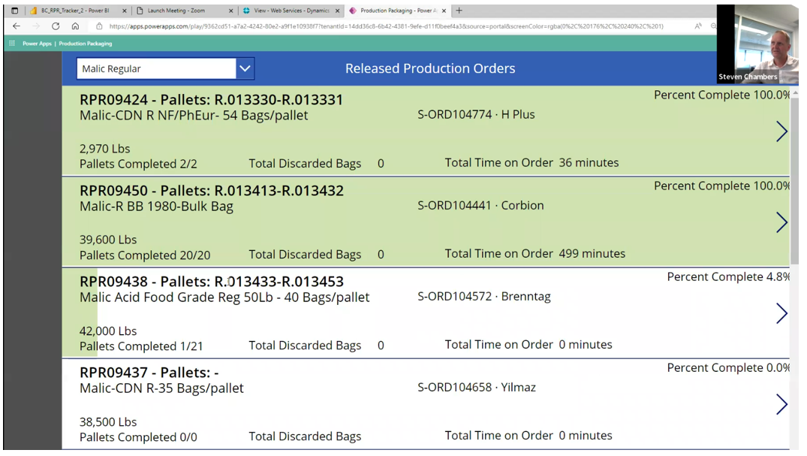

#### Business questions addressed and actions taken

### Data source

### Related tables

### Storage mode

### Current usage

### Target users

### Security and data restrictions

### Value thresholds

### Business criticality (availability)

### Possible improvements

## High-Level P1 Ops Dashboard

## Type - Operational dashboard

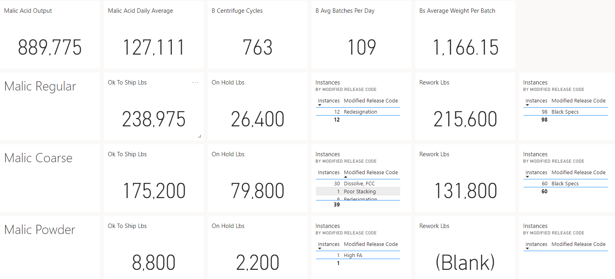

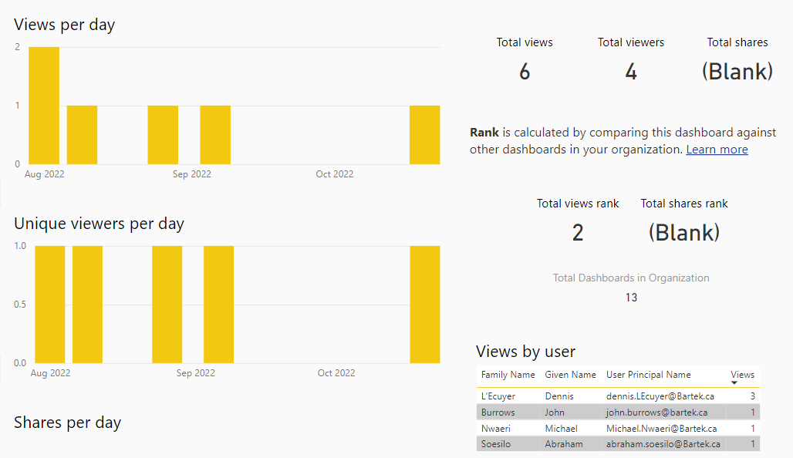

## P1 Operational Dashboard

### Overview

### Type - Operational dashboard

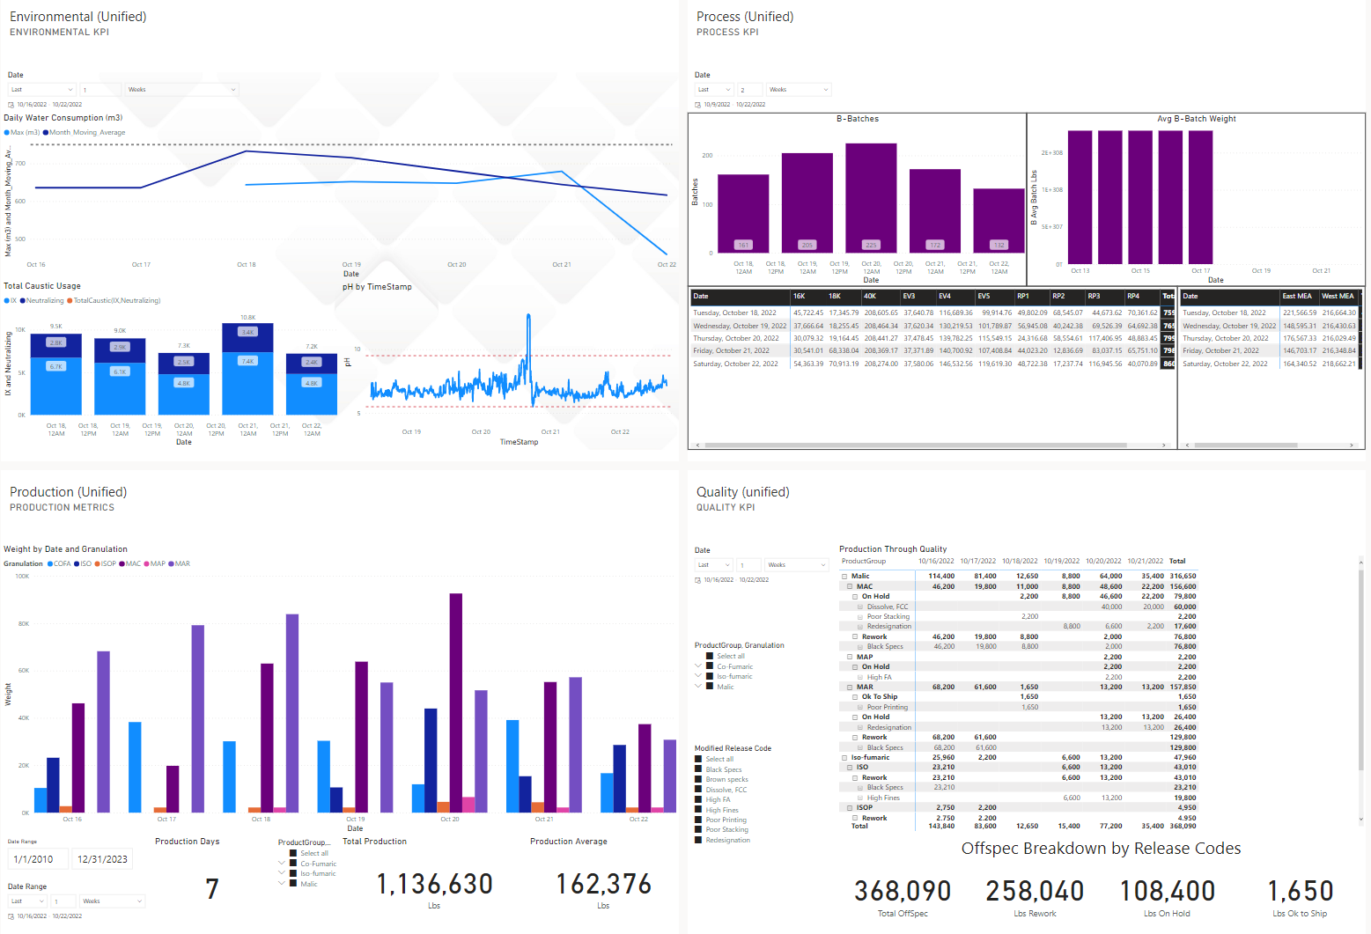

### Usage metrics

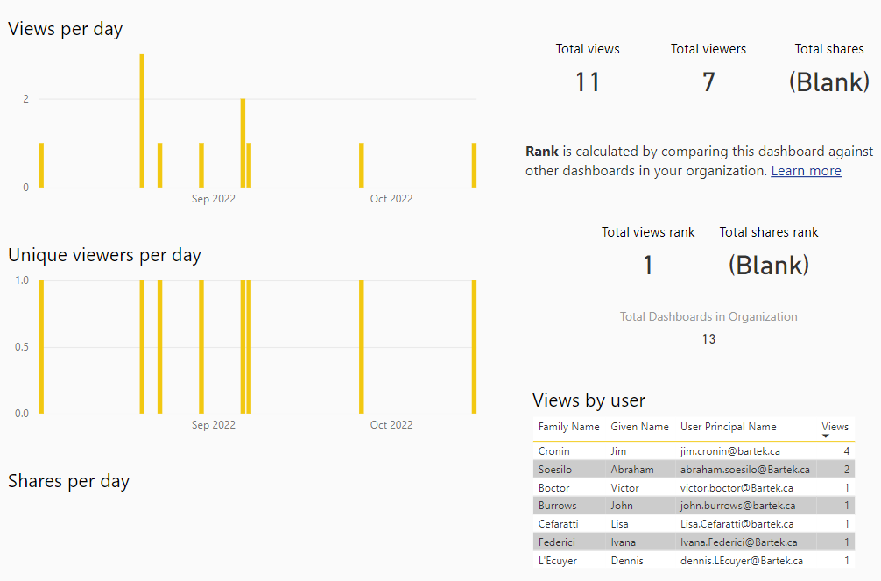

### Target audience

### Actions taken

## Automation opportunities

## Existing workflows

* Do you send reports to users via subscription or Microsoft Flow?
* Do you have any scheduled batch data processing? What are the reporting needs?

## Workflow production

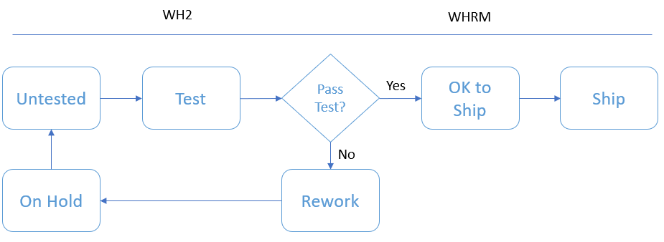

Note: Confirm with client

## Tools

* Power BI
  + Datasets?
  + Data Flows?
* Excel
* SSAS
* SharePoint - available, not implemented in the organization.
* OneDrive
* Power Automate
  + Flow
* Common Data Source/Dataverse

## Development teams and roles

* Steven Chambers
* Eric Turner

## Version control

## Project management tools

* MS Project?
* Agile/Kanban?

## Change management and adoption

* Gathering requirements
* Reporting usage metrics gathering and review

## QA and Deployment process

### Deployment schedules and windows

## Data archiving

## Color scheme

## Desired processes

* Allow users to build reports from validated data mart.
* Reduce the need to pull from transactional systems.

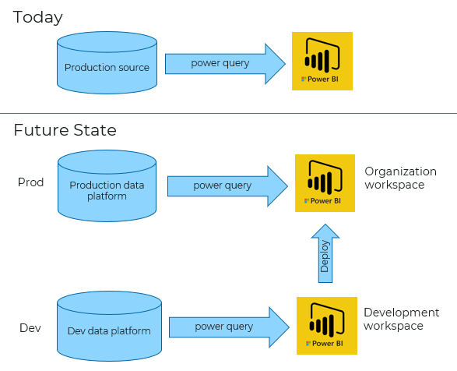

## Color scheme

* Reports should have a consistent look and feel.

## Development process

* Deployment should be methodical after testing
* Report development should not stress production workloads
* Workspaces should be organized according to business units
* Example workspace names: Development Finance Sales Purchasing Production

## Workspace access

* Manage working teams.
  + Identify working teams.
  + Set up Active Directory groups.
  + Apply AD groups to Power BI workspaces.